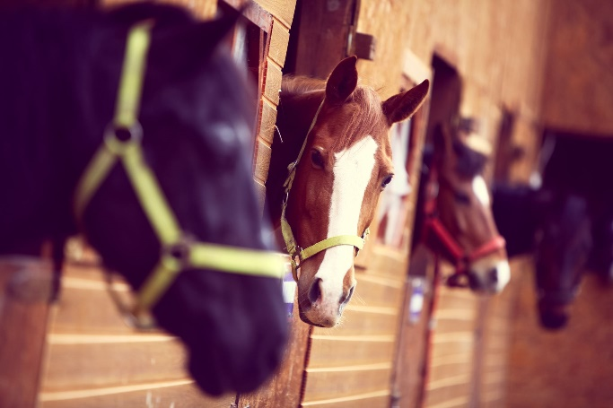
SOUTH LODGE STABLES
CAMP WEEKEND
FRIDAY 4TH JULY – SUNDAY 6TH JULY

This will be our 10th Camp held at South Lodge Stables.
We have enjoyed holding our Camps over the years and have met some lovely people and their horses.
We start from 6pm on the Friday evening and you are shown your to your stable. We provide hay, haylage and bedding for your horse and we provide all your meals.
After you have settled your horse for the evening we will have a demonstration (horse related) followed by a BBQ and quiz. This gives you the opportunity to meet fellow camp mates and new friends.
You are very welcome to stay over for both nights. Either in your horsebox, caravan or tent. We have plenty of toilets and showers available for you to use.
Meals provided for riders/spectators are:
BBQ Friday
Breakfast, Lunch and Evening Meal Saturday
Breakfast and Lunch Sunday.
Plus lots of snacks, hot and cold drinks. Please feel free to bring a cheeky bottle or two of your liking!
During Saturday and Sunday you will have the opportunity to participate in:
Rider fitness, Have a go at Judging, matchy matchy competition, best turn out, cleanest stable, tack and turnout.
Plus: Dressage, pole work, Jumping, Le-Trec, Gymkana, Riding Test and Display to Music.
The aim of this weekend is to come and enjoy yourself, make friends and make learning fun.
Everyone receives a large commemorative rosette, certificate of attendance and the chance to win lots of rosettes and trophies.
Full cost of the weekend for riders £200
Full cost for Spectators (non riding) £75
Per Day riders sat/sun £100
Per Day Spectator £40

To secure your place we require a £50 deposit for riders.
Payable to:
Mrs A J Peel
20-99-56
30688460

