SOUTH LODGE STABLES
FUN SHOWS 2025
SUNDAY 20th April Easter Show
SUNDAY 1st June
SUNDAY 10th August Summer Show
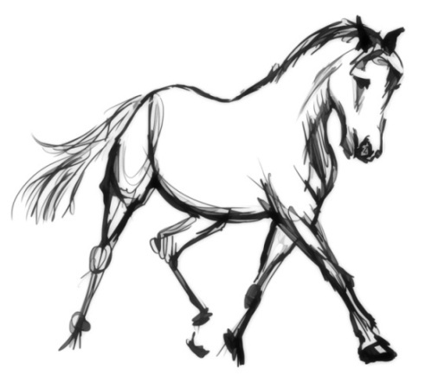
Venue – Show Field, Bolton Lane, Wilberfoss, York Y041 5NZ
Toilets, gates open 9am Refreshments available
Rosettes 1-6 in all classes
3 Championships
Sash and trophy to Best in Show and Reserve
All classes £9 per class (book 4 classes for £30)on the day £1 extra
All entries in advance classes will be restricted in numbers but will split into senior & junior if numbers permit
Payment through PayPal (Friends) southlodgestables@hotmail.com
Telephone: (01759) 388816 or 07393438494
Stay Safe At All Times

Ring 1 start 10am (In Hand Ring)

Class 1 First timers training class (open to any age to encourage people to learn and have a go)
Class 2 In Hand Tack and Turnout (any age & combination)
Class 3 In Hand Youngstock 1, 2, 3 years colt/filly, gelding
Class 4 In Hand Pony not to exc 148cms
Class 5 In Hand Horse to exc 148cms
Class 6 Best Condition Horse/Pony (will split if sufficient entries)
Class 7 In Hand Cob Type (Any Height)
Class 8 in hand Coloured (all types and sizes
Class 9 in Hand M&M (Small/Large)
Class 10 in Hand Veteran
Class 11 in Hand Thoroughbred
Class 12 Look A Like
Class 13 Prefect Partners
Class 14 Best Trick
Class 15 Best Handler up to age 12
Class 16 Best Handler from 12 -17
Class 17 Best Senior Handler over 17 years of age
Class 18 Fancy Dress any age/combination (Approved riding hat must be worn)

1st & 2nd from each class to compete in CHAMPIONSHIP
Champion and Reserve from each Championship will go forward into a best in show

Ring 2 Ridden Ring Starts 10am
(On Surface)
Class 19 Training Class (learn how to ride a show)
Class 20 Tack and Turnout any age
Class 21 First Timers Walk/Trot only
Class 22 Lead Rein (pony not to exc 128cm riders not to have attained their 10th birthday)
Class 23 Novice Ridden Walk/Trot/Canter
Class 24 Ridden Youngster 4,5,6 year olds (snaffle bridles no cantering as a ride)
Class 25 Ridden Coloured Horse/Pony
Class 26 Ridden Mountain & Moorland (Large/Small)
Class 27 Ridden Veteran 15 years and over
Class 28 Ridden Cob Trimmed/Traditional
Class 29 Ridden Partbred Horse/Pony
Class 30 Ridden Hunter exc 153cms
Class 31 Ridden Show Hunter Pony (not exc 153cms)
Class 32 Ridden Thoroughbred/ROR
Class 33 Golden Oldies Riders 45 years and over
Class 34 Equitation Rider not to attained 18th birthday
Class 35 Equitation Rider to have attained 18th birthday
Class 35a Champion of Champions class (for all best and reserve champions in shows from previous shows) for October 22nd Show only
1st & 2nd from each class to compete in CHAMPIONSHIP
Champion and Reserve from each Championship will go forward into a best in show

GOOD LUCK AND ENJOY YOUR DAY

Working Hunter Ring start 11am
Class 36 Poles on the ground ideal for beginners and lead rein
Class 36a Minimus working hunter 25cms ideal for lead rein/nervous novices. Open to junior and seniors.
Class 37 Novice Working rider any age 45cms
Class 38 For Piebald/Skewbald Horse/Pony rider any age 45cms
Class 39 Intermediate Working Hunte rider any ager 65cms
Class 40 Open Working Hunter rider any age 80 cms
Class 40 a We are offering competitors a chance to do a clear round of each working hunter class before they compete £7 per clear round. Please state which height.
Class 41 Pony Club type riders up to 17 years will consist of a show and 3 small jumps.
Class 42 Riding Club type riders over 18 years will consist of a show and 3 small jumps.

Working Hunter Championship 1st and 2nd from classes 36-42 to compete

ENTRY FORM
Show Date................................
CLASS | RIDER | HORSE | J/S | FEE

Name.................................................................................................

Address............................................................................................
..........................................................................................................
Contact number ..............................................................................
If paying by cheque please make payable to South Lodge Stables and post to South Lodge Stables Cottage,Bolton Lane, Wilberfoss,York Y041 5NZ.
All classes £9 per class (book 4 classes for £30)
entries in advance classes will be restricted in numbers but will split into senior & junior if numbers permit
Entries on the day £1 extra per class (4 entries £32)
Payment through PayPal (Friends) southlodgestables@hotmail.com
Telephone: (01759) 388816 or 07393438494
Check out our Facebook Page for updates and events

